**FAC Technical Summary**

FAC believe the Fund Management industry is facing a crisis, Fund Managers are seeking ways to improve performance to justify fees and charges to a changing investor community looking for better value. Part of the problem is the high cost of Fund investment compared to alternatives, largely due to the extended fund value chain made up of numerous intermediaries, each adding cost, time and risk.

The deployment of innovative Distributed Ledger Technology (DLT) provides a unique opportunity for the funds industry to achieve significant cost of operation, settlement timing, data timeliness and client service improvements.

FAC are at the heart of this change, designing and building the core solution and building the network of required participants for such a collaboration to succeed.

**1. What is Distributed LedgerTechnology?**

Until recently businesses have operated with their data and systems in silo’s, constrained by organizational, process and technical boundaries. Crossing those boundaries; participating in markets, collaborating across industries and scaling globally has required complex systems to exchange and reconcile data, the need for numerous intermediaries and the formation of centralized exchanges to facilitate interoperability and provide assurance of delivery and settlement. Although highly successful at providing growth and scale this approach is grossly inefficient, costly and prone to errors.

What if data could be shared transparently, transactions completed without intermediaries and payments settled immediately? This would dramatically lower costs, collapse value chains and reduce complexity, transforming business.

A distributed ledger is a synchronized set of data, shared across a network with multiple participants Each participant has a node on the network that allows them to share data and run applications. Security and trust in the integrity of data is maintained by use of cryptographic functions and consensus mechanisms. This creates a platform that businesses can more easily transact with each other directly without the cost and delays associated with intermediaries and centrally controlled markets.

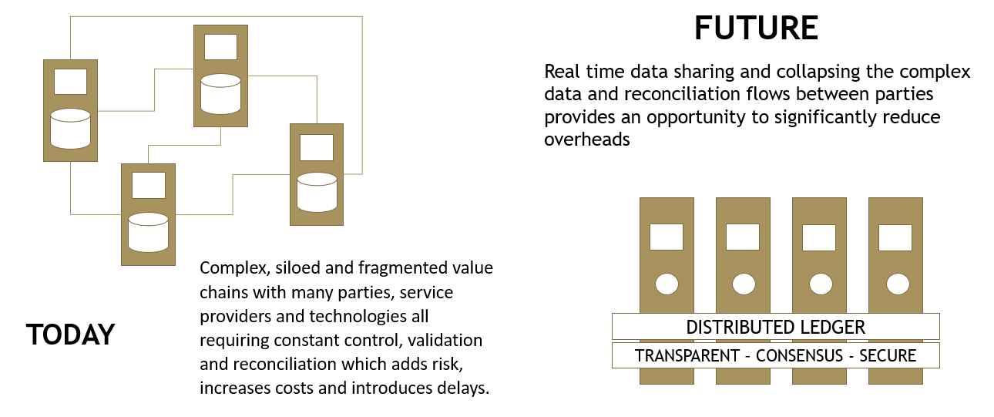

**2. A Distributed Ledger for Funds Servicing**

Investors in mutual funds soon discover there is a large number of intermediaries and servicing companies that are involved in the delivery of the products provided by fund managers. Fund administrators, transfer agents, custodians and distributors all serve roles in ensuring the integrity and security of the investment process but also add significant costs, delays and complexity into the process of buying and selling mutual funds.

By bringing together the principal participants in the mutual fund value chain onto a distributed ledger data can be shared quickly, transparently and securely without the messaging and interchange costs of today's networks, reconciliation processes are collapsed and settlement can be achieved instantly. It is not just investors that benefit from this, fund managers costs are reduced, additional markets are opened up and there are new insights into cash flows and investor behavior.

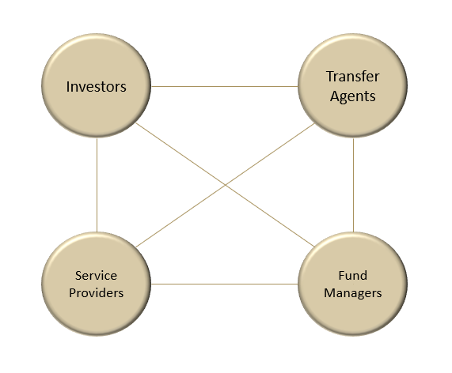

In addition to the principal participants, a funds servicing distributed ledger network provides digital custody, asset custody and cash settlement, liquidity and identity services. These participants join together in a heterogeneous network that delivers a low cost, trusted and scalable platform.

The opportunity of distributed ledger goes beyond optimizing processes across organizational boundaries. As more investors and fund managers join the network competition is increased, market efficiency is improved and costs are driven down whilst regulators benefit from real-time oversight of market activity.

Central to adoption of distributed ledgers for financial products is the ability to digitally represent cash and assets on the ledger, transfer title over these assets and provide finality of settlement and conversion back into fiat currencies. This process relies on tokenization, the digital representation of cash and assets in a distributed ledger (see next section). In the near future this process is going to transform the way all financial products are produced and consumed.

Initially existing assets, in this case the issued units of mutual funds, will be collateralized and represented as tokens on the distributed ledger but in time funds will be issued directly onto distributed ledgers allowing for even greater cost savings and a new generation of products to emerge.

**3. Tokenisation**

Tokenisation is the process of representing pre-existing assets (cash, securities or other financial instruments) in digitized form on a distributed ledger. These tokens are digital blocks of information which are cryptographically signed. Rather than entries in a database, these tokens are better thought of as promissory notes or IOU’s. Signed, immutable records of an asset which can be passed from one party to another.

These digitised assets derive their value from the collateralization of conventional assets which are held off the distributed ledger in safekeeping against the issuance of the tokens. The token is linked to these assets and holds the value and rights derived from them. To provide credibility to this process the entity collateralizing assets and issuing tokens on the distributed ledger must have sufficient financial and regulatory standing to guarantee the integrity of the issuance and provide confidence that investors money will be protected.

**4. Corda**

FAC is built on the Corda Distributed Ledger Platform.

[www.corda.net](http://www.corda.net).

Corda was developed in 2016 by R3, an enterprise software firm, in collaboration with over 200 technology and industry partners and now has a global ecosystem of developers.

Corda is an open-source distributed ledger platform written on Kotlin which allows developers to build interoperable networks that transact in strict privacy.

The Corda platform is already being used in industries from financial services to healthcare, shipping, insurance and more. It records, manages and executes institutions’ financial agreements in perfect synchrony with their peers, creating a world of frictionless commerce.

**5. FAC Network Architecture**

The Corda platform allows FAC to provide a specialized network for the funds servicing industry supporting order processing, registry maintenance and transaction settlement.

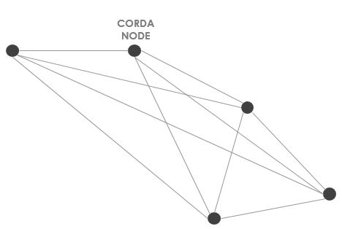FAC is a private permissioned network where each participant on the network has its own node and with access authenticated by a certificate issued by the network operator.

Communication between nodes is point-to-point using the Advanced Message Queuing Protocol (AMPQ) over TLS.

Transacting parties and participants only see the data relevant to their role and transactions.

***Node Structure***

Each participant node is a multi-layer system, consisting of the distributed ledger applications, data storage, integration and web access layers.

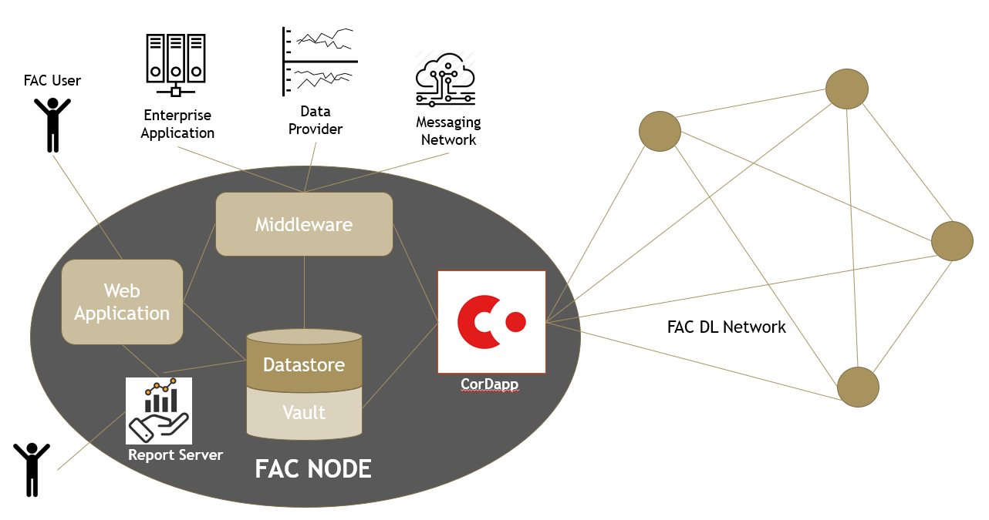

***CorDapp and Database***

CorDapp (Corda Distributed Application) is an application running on the Corda platform, and constituting the innermost layer of the FAC platform.

The goal of a CorDapp is to allow the participants to reach agreement with other network participants on updates to the ledger. This is achieved by designing and implementing (on Java and/or Kotlin) following class definitions:

* States (to define the facts over which agreement is reached);
* Contracts (to define what constitutes a valid ledger update); and
* Flows (to define a routine for the node to run, usually to update the ledger).

The flows can be invoked by the node’s owner from the more external layers: middleware or web.

All updates to the ledger are stored in CorDapp PostgreSQL database as immutable Corda states. At the same time, all sensitive data, including client’s personal data, is stored in CorDapp PostgreSQL database as GDPR compliant (editable and removable) table records.

***Middleware***

FAC middleware is JVM based software developed on Vert.x. It’s primary role is the intermediary between Web and Corda layers. Also, the middleware hosts gateways for interaction with external sources such as transactions messaging and payment services (e.g. Swift), fund price data sources and network participants internal systems.

***Web Application***

The web layer allows end-users (investors, distributors, funds and exchange administrators) to interact with the underlying layers (to send commands and receive system responses).  
The layer is written on TypeScript using ReactJS, MaterialUI and MobX libraries. It's compiled by WebPack and is running on a WebPack server.

***Reporting***

FAC uses JasperReports Server for reporting. It provides reporting and analytics that can be embedded into a web as well as operate as a central information hub for the enterprise by delivering information on a real-time or scheduled basis in a variety of file formats.

***Network Services***

**Network Map Service:** Corda nodes discover each other via a **network map service**. You can think of this service as a phone book, which publishes a list of peer nodes that includes metadata about who they are and what services they can offer. The network map service maps each well-known node identity to an IP address. These IP addresses are used for messaging between nodes.

**Notary Service:** A notary is a network service that provides both validating consensus and **uniqueness consensus** by attesting that, for a given transaction, it is both valid and it has not already signed other transactions that consumes any of the proposed transaction’s input states. The notary provides the point of finality in the system.

**Key Management Service (KMS):** The KMS is responsible for storing and using private keys to sign things. An implementation of this may, for example, call out to a hardware security module that enforces various auditing and frequency-of-use requirements. The KMS is a node level service.

**Corda Firewall:** Corda Enterprise includes a component called the Corda Firewall. The firewall is actually made up of two separate modules, called the bridge and the float. These handle outbound and inbound connections respectively. The Corda Firewall acts as an application level firewall and protocol break on all internet facing endpoints.

**6. Deployment**

FAC network nodes can be deployed either on premises or as a hosted solution. Running on Ubuntu the FAC network nodes can be delivered as fully configured containers for rapid deployment to cloud or local servers.

**For more information** please contact Chris Baldwin, FAC Delivery Manager, chris.baldwin@fundadminchain.com